**Men’s Mental Health – their way**

Jami Crego

Department of Social Work, Thompson Rivers University

805 TRU Way, Kamloops, BC. V2C 0C8

July 15th, 2023

**Abstract**

This study sought to explore barriers men face in accessing mental health services, identify areas of need, services, or resources that they have found most helpful, and the services that they would be most likely to participate in to help them manage life stressors and mental health concerns. 55 surveys were collected from mixed ages and ethnicities, and men were given the option to elaborate on their experiences in the survey. A large percentage of the men taking the survey answered that they had never used mental health services in any form, which is consistent with existing literature as well as gender stereotypes that describe men as being resistant to help seeking and more likely to mask distress. The responses that labelled ‘stigma’ and ‘concern over what others would think/embarrassment’ as cause for not accessing services indicate that hegemonic masculinity and environmental factors such as social conditioning significantly contribute to men’s hesitancy to access mental health services and underutilization of health services; gender stereotypes also contribute to the maladaptive coping behaviors frequently used.

Reviewing the men’s survey responses revealed some consistencies among the diverse range of answers on what is most helpful. Common themes of activities that men found helpful for managing stress included talking to friends and family, playing sports, exercise, and outdoor recreation. While men may have stated they would not be interested in speaking with a mental health professional, some of these same men indicated that they would be interested in a recreational group or in a casual peer support group.

Most respondents had experienced some episodes of severe stress or overwhelm within their lifetime. Alcohol and marijuana use were notably prevalent among maladaptive coping strategies, as well as emotional eating, avoidance, and expressing anger. Encouragingly, a significant number of respondents acknowledged they used exercise and speaking with friends or family to help them cope. Being able to share their feelings and concerns in a nonjudgmental and trusted space was also recognized as critical to receiving help; knowing that they were genuinely cared for was mentioned as key to who they shared their emotions with.

**Introduction**

*“From the start, I was taught to cowboy up and move on…” (Malarchuck, 2014, p.8)*

1. **Research Topic**

This research is exploring men’s mental health: their barriers to accessing it, specific life stressors, coping strategies they find most helpful, and how their preferred coping approaches could be utilized in developing mental health preventative and intervention services that men would find more helpful and more appealing.

Masculine stereotypes and early social conditioning contribute to worsening the stigma that surrounds mental health. Examining differences in men’s “health status, access to care, income, or health insurance” (Courtenay, 2011, p.178) is not enough to explain the lower use of health services of men compared to women. However, “this discrepancy can be explained… by looking at men’s attitudes toward seeking help” (Courtenay, 2011, p.178). Those who were the most firmly embedded in traditional masculine stereotypes such as stoicism were the least likely to seek help for symptoms; in rural areas, men are even less likely to seek help regardless of services available, possibly because of social expectations and gender norms (Courtenay, 2011, p.178). The result? Rural men commit suicide as much as three to five times higher than national averages (Courtenay, 2011, p.178), although men already commit suicide three times more often than women (Centre for Suicide Prevention, 2022).

1. **Research Purpose**

The project investigator hopes that by publishing a paper with men’s feedback regarding men’s use of mental health services and their preferences, perhaps it will encourage further research into the development of or tailoring of existing programs, so they are more appealing and helpful to men. By identifying maladaptive coping strategies and common stressors, services addressing these issues could be enhanced or reinforced. Through identifying and normalizing men’s mental health issues, hopefully this paper can also raise awareness of the need to remove the barriers men face when accessing mental health services. This stigma against men’s mental health is experienced throughout society, from within peer groups to even those providing health services (Scholz et al., 2022, p.413).

While one research paper may not feel substantial, it is a step in the right direction, but many more must be taken. Historically, men have been “socialized to perceive a link between showing weakness and feeling shame” (Scholz et al., 2022, p.412), beginning in early childhood. By five or six years old, boys are made to feel ashamed of their feelings, especially those involving weakness, vulnerability, or despair; they are also forced to separate from their mothers and any association of femininity early on (Pollack, 1999, p.11). Men’s status is affected by how they rank on a hierarchy established by their proximity to masculine ideals. This has become so ingrained in them and within society, that much work needs to be done to encourage help-seeking behaviors in men.

Service providers, developers and the men they seek to help would benefit from having a greater understanding of the “ways in which men recognize and utilize psychological growth through adversity, engaging in positive cognitive reframing, use of humor, and seeking education and information” (Spendelow & Seidler, 2019, p.106).

1. **Significance of the Research Project**

*“I suffered swirling bouts of anxiety that I didn’t fully understand at the time. It’d been with me ever since I was a kid…I had just learned to live with it, acting like nothing was wrong in public, but knowing it was slowly destroying my personal life.” (Malarchuck, 2014, p.68).*

Although men may be proficient at wearing a ‘mask’ and hiding their distress, unresolved issues do not just disappear. Maladaptive coping strategies as well as untreated and escalating symptoms cause further damage not just to men, but the community around them. Pollack expresses this well in his book, *Real Boys*:

*“…on the outside, the boy who is having problems may seem cheerful and resilient while keeping inside feelings that don’t fit the male model-being troubled, lonely, afraid…Boys learn to wear the mask so skillfully…that it can be difficult to detect what is going on when they are suffering…to the point of feeling suicidal. The problems below the surface become obvious only when boys go ‘over the edge’, and get into trouble at school, start to fight with friends, abuse drugs or alcohol, are diagnosed with depression or ADD, erupt into physical violence…”* (1999, p.5).

Previous research has found that boys and men tend to “minimize their pain” (Pollack, 1999, p.312) and one study found only “26% of boys polled said they would ask their friends for help” (Pollack, 1999, p.313). Men’s expression of distress often displays differently from women’s, but mental health services and diagnoses often “use the same diagnosis criteria designed for female expression of sadness” (Pollack, 1999, p.306).

This study focuses specifically on men’s concerns and coping strategies to encourage consideration of gender when evaluating men’s mental health or designing programs for them. It is critical to do this because less than half of people with mental illness access professional services (Grant & Potenza, 2007, p.391) and men are especially likely to be left out: extensive studies have “almost universally demonstrated that men are less likely than women to seek professional help with mental health providers for their emotional problems” (Grant & Potenza, 2007, p.390).

**D.** **Guiding Research Questions**

The research questions that directed this study were what coping strategies men use, which areas of life contribute to men’s stress or otherwise deteriorate their mental health, and what services they would find most appealing. The study also considers what barriers prevent men from accessing mental health services, and what strategies they have found most useful for managing their mental health without professional support.

**Literature Review**

Although men have been seen to have some privileges in society, such as the opportunity for high paying employment and leadership, this does not extend to all men and even when they have social advantages and equal or greater access to “health related resources… men- on average – are at a greater risk of chronic disease and injury than women” and have shorter lifespans (Courtenay, 2011, p. 3). The fifteen leading causes of death are, in order from highest to lowest: heart disease, cancer, stroke, lower respiratory disease, accidents, diabetes, Alzheimer’s disease, influenza and pneumonia, kidney disease, septicemia, suicide, liver disease and cirrhosis, hypertension, Parkinson’s disease, and homicide (Courtenay, 2011, p.4). In nearly all age groups, men and boys die at higher rates than women and girls from these causes, regardless of any social advantages; “the greatest gender disparity is the death rates for suicide and homicide, which are four times greater for men then they are for women (Courtenay, 2011, p.4). A third of deaths of males under forty-five years are through violence- they make up three-quarters of homicides and 35% of men killed in this age group die through violence (Courtenay, 2011, p.5). Overall, the suicide rate for men is three to four times that of females, ranging from 2-18 times higher across all age groups 10-84 years, and is the 8th leading cause of death for men (Courtenay, 2011, p.6; Centre for Suicide Prevention, 2022). Despite their proportionately lower use of mental health services, these numbers indicate that men’s mental health is a concern, and there is a need to reduce barriers to treatment and increase service options.

Heart disease and cancer account for approximately 50% of all deaths, and men experience chronic health conditions at high rates (Courtenay, 2011, p.4)- these statistics could possibly be attributed to unhealthy coping strategies, denial of distress and issue avoidance, and refraining from receiving treatment until their conditions are severe. Although men’s mental health, coping strategies, and masculine stereotypes affect their health behaviors and lifestyle choices, contributing to these issues, “men’s poor health practices are rarely addressed by health scientists” (Courtenay, 2011, p.172). Mental health should not be ignored by the medical system, as “psychiatric problems also increase men’s physical health risks…mental disorders are a leading cause of premature death” (Courtenay, 2011, p.7). Men face and or perceive discrimination and stereotyping both among their peers and society, but as well as from those providing the services intended to help them due to societal norms.

Another concern is the damage caused to men (and others) through violence and injury. Risk taking is expected by masculine norms; under 45 years, accidental injuries are the leading cause of death for men and boys and roughly three-quarters of those who die from them are male; three-quarters of traumatic brain injury victims are also male (Courtenay, 2011, p.5-6). Effect on others

The risks men take, and decisions made if abusing substances or through harmful coping strategies affect those around them. For example, men cause “most automobile accidents … (and) high risk sexual practices that are largely responsible for the continued spread of STDS” (Courtenay, 2011, p.10).

**Incidence of mental health concerns/stressors**

Research involving national data has consistently found that during their lifetime, men are as likely to meet psychiatric diagnoses criteria for mental health issues and illnesses, and some, such as “antisocial, narcissistic, obsessive-compulsive, paranoid schizoid and schizotypal personality disorders are all more common among men” (Courtenay, 2011, p.6). Approximately ten percent of men will experience a major depressive episode (Grant & Potenza, 2007, p.108). Boys receive ADHD diagnoses as much as “9 times more often than girls” (Courtenay, 2011, p.6) although some of this could be due to tendencies to label boys expression of emotions as problematic. Men and boys are also five times more likely to have autism or Aspergers syndrome (Courtenay, 2011, p.6).

Wilson et al. studied the coping strategies of men during the Covid pandemic, due to it’s creation of situations known through extensive research to cause psychological distress and increased suicide risk in men: “job loss, unemployment and financial stress…relationship breakdown and social isolation” (2022, p.2). Lockdowns causing unemployment during the pandemic contributed, if not caused, the higher number of suicides seen in men throughout it (Wilson et al., 2022, p.2). Some men admitted that during the pandemic, they were aware that their increased use of “screen time…which included greater pornography consumption, as well as increased alcohol and substance misuse” was problematic; alcohol and marijuana were the most popular substances to use (Wilson et al., 2022, p.6).

**Help seeking/ service use**

Stigma has been recognized as a major barrier to men’s help-seeking. Grant & Potenza identified that “male-role socialization and socially prescribed male gender roles as barriers to help seeking” (2007, p.394) as for a man to admit he needs help undermines expectations of masculinity. Scholz et al. explored men’s access to mental health services and found that their participation “depends on ensuring a diversity in mental health services offered, availability and visibility of services, and relationships with service providers” (2022, p.412).

Despite the prevalence of men’s health issues, their predisposition towards denial can be seen in the stat that out of everyone who has not seen a doctor in five years, 75% are men, and “research has consistently shown for decades that men are less likely than women to receive help for mental health problems or for substance abuse” (Courtenay, 2011, p.12; Grant & Potenza, 2007, p.390; Scholz et al., 2022, p.412). By denying that they need help, men can reinforce their masculinity, despite the harm created (Scholz et al., 2022, p.413). If men do seek support, often the lack of appropriate services limits their options to seeing a general practitioner, who may prescribe medication or put them on a long wait list for counselling or cognitive behavioral therapy (Vickery, 2022). If hotlines and virtual services do not have enough staff, men reaching out may be discouraged by the lack of support and not attempt to contact them again.

How ‘normal’ a problem is perceived to be affects help seeking- when an issue is normalized, it was found men were more likely to accept help (Courtenay, 2011, p.253). Beyond stigma, concerns regarding loss of autonomy, fear of vulnerability, financial concerns, protection of privacy, and distrust of medical and psychiatric professionals reduce men’s help seeking behavior (Courtenay, 2011, p.258).

**Hegemonic masculinity/stereotypes/stigma**

Multiple studies show that stigma and expected gender roles are a significant barrier to men’s help seeking. Hegemonic masculinity rewards those who are close to the ideal and condemns those who deviate: “male ideology places a premium on self-reliance, and the inability to solve one’s own problems is viewed as a sign of weakness” (Grant & Potenza, 2007, p.397). By requesting help, men are exposed to “potential social rejection and feelings of low self-esteem associated with acknowledging an inability to manage the problem” (Grant & Potenza, 2007, p.398). Masculinity is on a hierarchy, and the farther a man is from the ideal, the more shamed he may be exposed to or feel; they ‘lose status’ in society (Scholz et al., 2022, p.413).

Mental illness is already associated with negative connotations such as “violence, childishness, and incompetence” and devaluing statements and stigmas are frequently condoned and reinforced by medical and mental health professionals, with greater discrimination shown towards those struggling with mental health issues (Grant & Potenza, 2007, p.398).

William Pollack has worked extensively with boys, and he explains that gender stereotypes are enforced early on:

“*Boys are made to feel shame, over and over, in the midst of growing up… the idea is that a boy needs to be disciplined, toughened up, made to act like a ‘real man’, be independent, keep the emotions in check…. If all these things are not said directly, these messages dominate in subtle ways in how boys are treated and therefore how they come to think of themselves*” (1999, p.11-12).

Antisocial personality disorder exists worldwide, with a global prevalence rate of between 2%- 4% of men, and is “associated with male gender, incarceration, low socioeconomic status, drug and alcohol misuse, and homelessness” (Grant & Potenza, 2007, p.151). Cultural factors that cause this disorder to occur predominately in men may be that men are socially conditioned to externalize their pain, anger, and frustration into aggression (Grant & Potenza, 2007, p.152).

The coping strategies used by men are enabled by “masculine gender role scripts” that promote avoidance, distraction, and minimizing (Spendelow & Seidler, 2019, p.120). A diverse range of coping strategies are used, but those that emphasize avoidance and minimization are seen most often as they align with hegemonic masculinity’s expectations (Spendelow & Seidler, 2019, p.120). Because of stigma and gender norms, focus is often shifted from the psychological to the physical; or positive aspects of their habits are exaggerated to distance themselves from the negative connotations assigned to emotional distress (Scholz et al., 2022, p.413). Programs addressing men’s needs should consider this and use wording or activities that allow men to save face while discreetly receiving help.

These stereotypes can also cause male-specific programs to reinforce masculine stereotypes. For example, “one assumption is that men primarily want information-focused health care, despite research suggesting it is not uncommon for men to prefer discussing concerns over receiving information” (Scholz et al., 2022, p.413). There is great diversity in preferences, so more flexible programming guided by client needs would likely be more inclusive than this approach.

Other false assumptions about men seen in service provision is the assumption that “men need women to push…them to health services” which excludes men in a different or homosexual relationship situations (Scholz et al., 2022, p.413). Another is overemphasizing that “stereotypically masculine programs” are needed for men to participate- “however, research exploring common portrayals of men with depression critiques such assumptions, arguing they infantilize men and position them as not in control of their health” (Scholz et al., 2022, p.413).

**Coping Strategies**

Unhealthy coping strategies seen in men include alcohol and substance use, tobacco use, poor dietary habits, and inactivity. Risk taking and impulsive behavior is also seen; happily, coping strategies such as exercise and outdoor recreation are also popular. While substances may be used for stimulation and ‘thrills’, in the mental health context they are being used to self-medicate anxiety, depression, and mental illness.

The top three substances abused are alcohol, marijuana, and nicotine, with respective rates of 6.7%, 9.3%, and 26.5% (Grant & Potenza, 2007, p.121; Wilson et al., 2022, p.6). Men interviewed on their substance use were found to have “lower levels of concern then would be expected/realistic with how substance use is impacting them” (Grant & Potenza, 2007, p.122; Wilson et al, 2022, p.6) which corroborates men’s ability to minimize issues, consciously or unconsciously. Men recruited from substance treatment programs for mental health studies were found to have weaker coping skills and a higher incidence of personality disorders (Grant & Potenza, 2007, p.122; p.125). Having to restrict emotional expression due to gender roles is associated with higher levels of substance use and destructive coping strategies (Grant & Potenza, 2007, p.123; Pollack, 1999, p.309).

There is a correlation between men’s distress and alcohol use, with research consistently demonstrating “greater problem drinking and heavy drinking among men and a higher prevalence of alcohol abuse and dependance… men account for 81% of all binge drinking episodes” (Courtenay, 2011, p.86). Male gender has been found “to be strongly and independently associated with binge drinking” (Courtenay, 2011, p.87). Alcohol use is linked to medical complications, such as cancer, cardiovascular disease, diabetes, and cirrhosis, all of which are among the top fifteen causes of death (Courtenay, 2011, p.87). Drinkers are also more likely to use tobacco, have unhealthy diets, and be inactive (Courtenay, 2011, p. 88). In youth aged 12- 20, excessive alcohol use “increases the risk for the three leading causes of death in this age group- unintentional injury, homicide, and suicide” (Courtenay, 2011, p.88). Alcohol’s removal of inhibitions can cause aggression, violence, recklessness, and other harmful behaviors (Grant & Potenza, 2007, p.123) as well as be a factor in completed suicides.

Anabolic steroid use is becoming more common, with 4% of men having tried steroids by thirty years of age and is a “predominately male phenomenon” (Courtenay, 2011, p.90). Hegemonic masculinity favors size and muscle mass; steroids are one way for men to achieve this, and they are primarily used to enhance these masculine attributes (Courtenay, 2011, p.90). The emphasis placed on body image has led to increased use of steroids, despite research confirming short and long term health effects of their use, such as withdrawal symptoms that include severe depression and suicidality (Courtenay, 2011, p.90). Alarmingly, they are also proven to cause ‘roid rage, jealousy and possessiveness of women, abuse, violence, paranoia, and homicide (Courtenay, 2011, p.91). Used with other drugs, the side effects can be more severe.

Stressors can lead to greater impulsivity and risk taking behaviors, as well as persevering despite the risk of bodily harm. Three- quarters of those with traumatic spinal cord and brain injuries are in males, and injury is the leading cause of death in men under 45 (Courtenay, 2011, p.92). Specific risk taking behaviors frequently seen in men include “reckless driving, drinking and driving, safety belt use, sexual activity, sport and recreation” (Courtenay, 2011, p.92).

As stoicism is reinforced and anger is often the only permissible emotion for men to display based on gender norms, it should not come as a surprise that “male gender is the *only* risk factor consistently associated with the perpetuation of violence” (Courtenay, 2011, p.103). A national study found that half of men had been punched or beaten, and 44% had been in a fight in high school and beyond (Courtenay, 2011, p.103). Social conditioning has led males to be more likely to see fighting as the correct way to resolve a dispute or get retribution (Courtenay, 2011, p.104). Men account for 90% of violent convictions (Courtenay, 2011, p.106).

**Research Design**

1. **Sampling**

This study uses convenience and cluster sampling methods. To find participants, the researcher used posters advertising the study, word of mouth, and asking random individuals at public locations around Kamloops and Williams Lake, such as parks, recreation centers, and farmers markets. A total of 55 complete surveys were collected for the study. Participants were told they were not required to answer any questions they did not want to; as a result, the ethnicity and ages of participants may not reflect the exact percentage as some men did not want to share their age. Most respondents skipped the question about their ethnicity, so it has been omitted from the study because it is guaranteed to be inaccurate.

From what is known, 12.7 % of participants identified as Indigenous or Metis. Ages ranged from 18-82 years of age, with the average age being between 30-31 years old. The majority are employed full time (69%). 14.5% of participants were retirees, 5.4% were unemployed, 1.8% worked part time, and 1.8% were unemployed.

1. **Methods of Data Collection**

Data for the study was collected through paper surveys, that mostly contained multiple choice, ‘select all that apply’ questions, but also provided space for participants to share their own thoughts regarding men’s mental health and related programs. The men’s names and contact information from the consent form were retained for use in a prize draw but kept separate from survey answers. All data was anonymized, and no identifiers were kept or used in the final report.

This study used a mixed methods approach, using the survey as well as research of existing literature to collect data. Both qualitative and quantitative data were collected and considered in the surveys and review of literature, and then synthesized. Comparing the survey results to past research on men’s mental health was essential in identifying themes, as well as checking the validity and reliability of the survey results through other sources.

Data from literature sources was harder to come by due to the paucity of mental health research on specifically men’s mental health needs. Courtney’s book, *Dying to be Men* (2011) is cited frequently in this report as it is the most inclusive and relevant literary data source that the primary researcher found. The researcher has read a variety of resources, recent and from past decades, and found that the patterns and findings shared in that book appear consistently across numerous other resources. In informal conversations with men, and the data collected from this study’s survey, the book’s representation of men’s health issues and preferences continued to hold true.

1. **Ethical Considerations**

Certain aspects of mental illnesses were left out of the survey in this study, such as suicide. Although suicide in men is an important issue, due to limits of confidentiality and duty to report, it was not included in this study and was determined to be beyond its scope. However, the mental health concerns and stressors examined in the study contribute to men’s suicide rates, so it is critical and of value to address them. Sensitive subjects such as risk taking through sexual activity and promiscuity were also omitted, for similar reasons, although touched upon in the literature review.

Men were given the surveys and consent forms in a legal envelope that could be sealed, to further protect their privacy and ensure that only the researcher would see their answers, and no passing eyes. The researcher hoped that the extra effort to protect their privacy and be discreet would make the men feel more comfortable in submitting the survey and reassured that their right to confidentiality was being taken seriously. Consent forms and surveys were divided into separate folders and mixed, so that participants could not be connected to their responses.

1. **Limitations**

There are several limitations to this study that need to be considered when reviewing the results. Although the quantitative data from the surveys may be free of bias, more interpretation and analyses is required of the researcher when synthesizing data from numerous sources, coding date, and identifying themes. As the researcher is a female, her perspective and worldview may lead to a different interpretation than if a male were to be doing the analysis.

The study is also intended to contribute to existing research on men’s mental health and related services and explore which service’s men find most appealing or are most in need of, based on their stressors and preferred coping strategies. For this reason, men are invited to include their own narrative at the end of the survey about their suggestions for mental health services, although not all did. Due to geographical limitations, the researcher surveyed men from Williams Lake BC., and Kamloops, BC. Due to the diversity of individual’s experiences, personal characteristics, needs, and preferences, this study can not be applied to the entire male population. Williams Lake is a municipality with a large rural population; findings have shown that rural men are more likely to hold rigid masculine stereotypes and abuse substances, which could skew the results (Courteny, 2011, p.177-178).

The study could also be improved by focusing on less issues to get more pointed answers, rather then casting such a ‘wide net’. Or by asking participants to specify *why* they chose their preferred coping strategies, and *what it was about them* that helped alleviate their distress. It could also further investigate existing literature and study results on the effectiveness of experimental prevention and intervention programs that have been directed at men.

**Data Analysis and Interpretation**

“*I was probably weak until mid-July, but I didn’t tell anyone. And no one talked to me about any psychological effects. I didn’t know the meaning of trauma then, but I knew the meaning of being a total pussy, and I sure as hell wasn’t going to be one” (Malarchuck, 2014, p.90).*

**Survey Results**

When reviewing the completed surveys, the researcher did a content analysis and counted the frequencies each option was selected for multiple choice questions, then calculated the percentage of participants who selected that answer in order to create a visual and compare the survey results to other studies’ findings. *As participants were told to select ‘all that apply’, the percentages in many cases do not add up to 100% as usually multiple answers were chosen.*

One question asked participants to rate their current stress level between a ‘one’ and a ‘ten’, with one being the lowest possible and ten being the highest. The average response of the men’s self-evaluation of their stress levels was 3.11. Even if men also answered that ‘yes, they had experienced mental or emotional health concerns over the past 12 months’, their perceived stress levels were still usually close to this average. Men’s socialization to suppress feelings could lead to “genuine difficulty in identifying their affective response to a stressor in order to estimate its severity” (Grant & Potenza, 2007, p.396). This is seen in the amount of men who reported issued with stress and overwhelm and mental concerns, but still rated themselves as experiencing low stress (under five on a scale of one to ten, with ten being the highest). The highest score given on this scale was a seven.

Over the past year, 43.6% of respondents said that ‘yes’, they had experienced emotional or mental health concerns, and 56.4% said they had not. Over their lifetime, 38% had experienced mental health concerns, 38% had had issues with substance abuse, 54.5% had experienced severe stress and overwhelm, and 21.8% suspected they would meet the criteria for a mental health diagnosis. 9% had their mental health diagnosis confirmed, and 23.6% answered they had no concerns in any of these areas.

To try and gauge the severity of men’s coping habits, the survey asked whether the men had concern expressed about their coping choices, been told to ‘change’ them, or had their coping or self-medicating impact their ability to manage the generally accepted essentials for a functioning life (e.g. able to have shelter, food, and employment). 30% had had concern expressed and 65.5% had not; 36% had been told they needed to change and 61.8% had not. 80% of respondents said their coping behaviors did not impact their ability to function.

To identify factors that affect men’s mental health, the survey asked men to answer which of the categories listed were impacting them. The purpose was to assess common stressors, as well as identify a need for future programs to focus on in their design. Finances were the number one leading concern, with 52.7% of men listing it as a worry. Family accounted for the second highest percentage, at 38.2%, and work came third at 34.5%. In order from highest to lowest percentage of men affected, the remaining categories of stressors were health at 32.7%, loneliness at 20%, social at 16.4%, relationships at 14.5%, housing at 10.9%, addictions at 5.6%, and school at 1.8%.

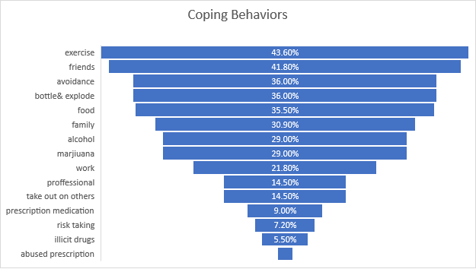

The results of men’s preferred coping behaviors both aligned and deviated from the common theme of the literature read prior to the study. The use of substances, primarily alcohol, marijuana, nicotine, and illicit drugs is a common concern regarding men’s management of their emotions. This study did not address the use of tobacco but inquired about alcohol and drug use. Consistent with existing literature, there was a significant use of drugs and alcohol to cope; however, these were not among the top coping strategies listed by men during the survey.

‘Exercise’ took the number one spot with 43.6% of participants crediting it with helping maintain emotional stability, and ‘speaking with friends’ was utilized by 41.8% of respondents. Participants were encouraged to select ALL that applied, so these healthy and positive coping strategies were sometimes also paired with less helpful options. Still, it is encouraging to see a large number of participants able to identify and use beneficial and pro-social means of coping. ‘Avoiding the issue’ and ‘bottling up and then exploding’ tied for third, with 36% of respondents identifying with at least one of these. Given the pressure to conform to hegemonic masculinity and conceal their emotions, this result aligns with expectations for men to be ‘stoic’ or ‘aggressive’. 34.5% of men found comfort in food, which could be considered similar to using a substance to distract from uncomfortable feelings. 30.9% turned towards family and other informal social supports to alleviate stress.

Alcohol and marijuana abuse both tied, with 29% of respondents using one or both substances. 21.8% buried themselves in extra work, once again aligning with society’s expectations of men to buckle down and be the ‘bread winner’- whether this is a positive or negative coping strategy really depends on the context and the consequences of doing so. 14.5% have spoken with a professional; unfortunately, 14.5% also find taking their issues out on others cathartic. 9.1% have used prescription medication to manage, and only 1.8% of prescription drug users said they abused theirs. 7.2% engaged in excessive risk taking activities in response to distress, and 5.5% admitted to using hard, illegal drugs.

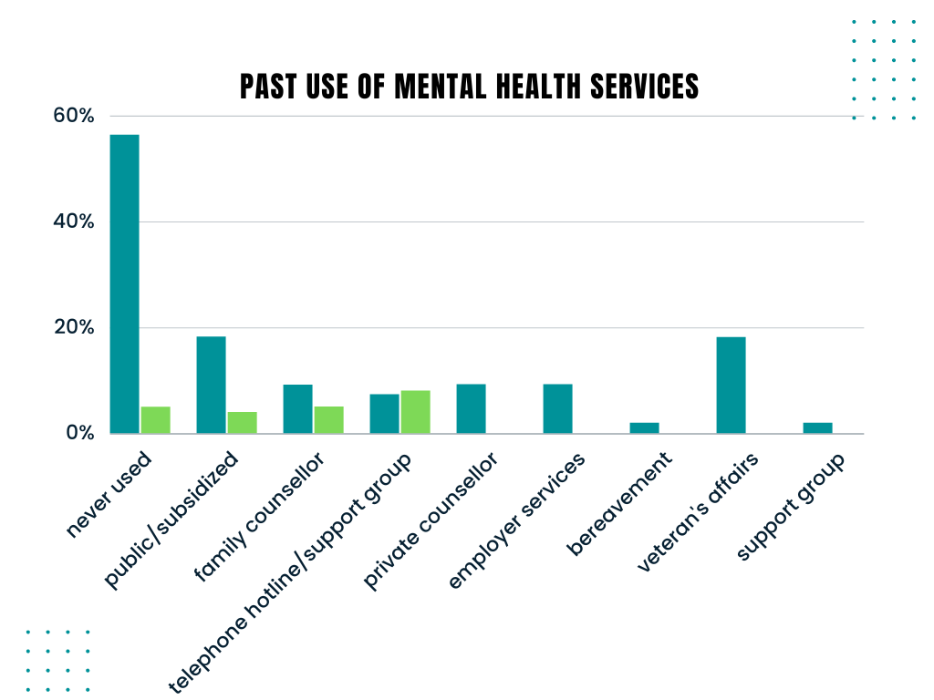 As past experiences can affect future behavior, the survey asked men which type of professional mental health services they have used in the past. 56.4%, by far the largest percentage of responses, said they had never used one, which reinforces the rhetoric that men can be resistant to help-seeking. 18.2% said they had been to a public or subsidized mental health practitioner; 9.1% had seen a family counsellor, been to a private counsellor or used mental health services provided through their employer. 7.3% have used a telephone hotline or a support group. Veteran’s affairs, bereavement services, addictions and inpatient treatment were each used by 1.8% of respondents.

To understand what prevented men from accessing professional services, participant’s were asked to indicate their reasons for not seeing a mental health practitioner for their concerns. 27.3% felt uncomfortable and self-conscious, and 23.6% said nothing available met their needs. The medicalized or unappealing environment turned off 14.5% of them, and stigma prevented another 12.7% from reaching out. 7.3% said they disliked the available practitioner, and 7.3% were worried about what others would think of them if they knew. Worries about repercussions at work stopped 5.5%. Although only one directly attributed not contacting services due to stigma, the majority of responses regarding others perception of them as a result of help seeking indicated that masculine social norms and a double stigmatization against mental illnesses and men who admit to needing help, was a barrier for many men (Scholz et al., 2022, p.412).

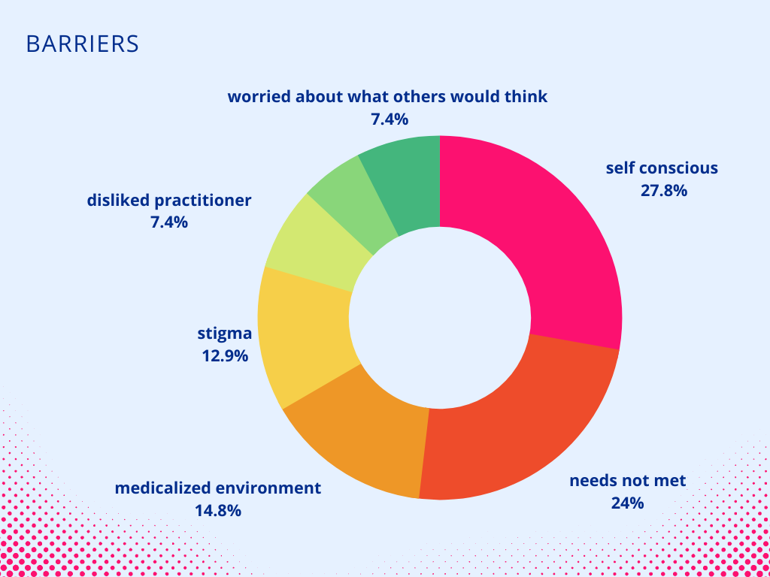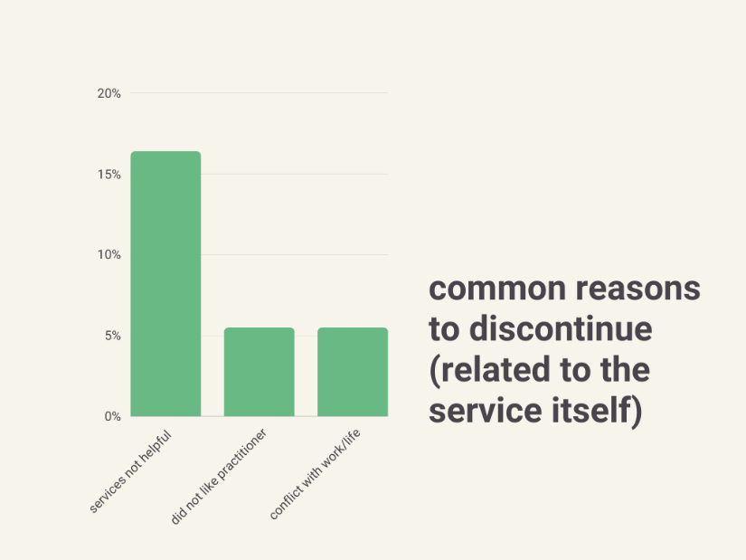

Of the men who accessed services but discontinued them, 16.4% said the services were not helpful, 5.5% did not like the practitioner assigned to them, and 5.5% found treatment conflicted with work and other life responsibilities. In an optional section to include other comments, some men said they recovered and no longer required help; a couple others said they were still receiving services. Cost was also mentioned as a barrier in the comment section, either because they could not afford the help offered or in the case of one individual, “*the practitioner I found helpful was no longer covered by insurance*”.

Due to men’s proportionate underuse of health services, the study wanted to identify what informal supports men used, in the hopes that by integrating these into current mental health services, it would improve accessibility, and connect more men to mental health supports. Since stigma and gender norms have been determined to be a huge barrier to accessibility, by understanding what *is* acceptable to men, practitioners could design and advertise their services in a way that is more appealing.

63.6% of men surveyed found support through recreational groups and activities; 60% turned to friends and 50.9% turned to family for support. 21.8% felt comforted by their pet, and 16.4% found support through coworkers. Social groups were used by 14.5% of respondents.

Participants were asked which recreational activities they received the most benefit from. Individual preferences vary widely, so answers were organized into categories for content analysis. Sport, exercise, and outdoor recreational groups and activities all ranked highly, with 47.3% of men participating in something in at least one of these three categories. There is also overlap within the categories, as they often have outdoor, health and exercise, and a social component, maximizing the benefits possible through them. Motorsports, such as driving or working on vehicles, and dirt biking, accounted for 14.5%. Groups revolving around video, board, or indoor games received 12.7% of respondents, and 9% of men listed activities that didn’t share a common theme, such as reading, music, and meditation.

Following this theme, the survey asked men what services they would be most likely to use or find helpful if they were available. 34.5% answered a recreational group activity with a goal to reduce stress (or other); 25.5% said they were most interested in sport or athletic groups. 21.8% thought an informal organized peer group would best suit them, and 16.4% thought a skills specific educational section would be helpful. For services with a professional, 16.4% said they would be interested in one in a formal setting and 12.8% said they would prefer an informal setting. 5.5% were interested in support groups focusing on a specific issue, and 1.8% said all options interested them.

**Discussion**

*“There was still such a stigma around mental illness… there was an asterisk beside my name now; the footnote read ‘crazy’. My reputation brought to mind words like unpredictable, uncontrollable, uncooperative, unhinged- unemployable. Who the hell hires crazy?” (Malarchuck, 2014, p.229).*

The average stress level reported by men in the survey was 3.11 (from a scale of one- ten, with ten being highest). Yet when reviewing their answers, men who rated themselves as low stress sometimes still indicated that they had emotional concerns over the past year, and multiple stressors. This low number could be partially attributed to that “even when physiological responses to a stressful event are greater among men than women, men still report less distress” (Courtenay, 2011, p.14).

Men often respond to stressors with unhealthy coping strategies that generally avoid or distract from the issue, “such as…increased alcohol consumption- and are less likely to use health, vigilant coping strategies and to acknowledge that they need help” (Courtenay, 2011, p.11). Further stressors lead to greater risk taking or activities detrimental to their health, such as “cigarette smoking, excessive alcohol or coffee consumption, and lack of exercise” and other efforts to distract (Courtenay, 2011, p.11). Unfortunately, these responses and the denial of distress has been found to cause or exacerbate psychological issues (Courtenay, 2011, p.11). Suppressing emotions also can backfire, as several men admitted to exploding with anger when they could no longer bury their stress.

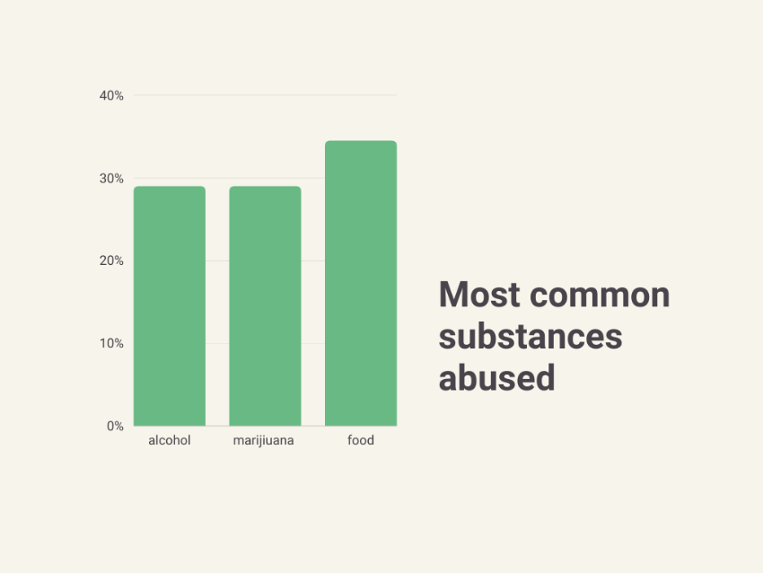 This study found that 29% of participants used marijuana and/or alcohol to alleviate stress, but not identify the severity of their use. That an estimated 12% of men are dependent on or abuse drugs and alcohol (Courtenay, 2011, p.80) confirms this is a popular but maladaptive strategy. Correspondingly, 38% of respondents had concerns with substance abuse; 5.6% listed their addiction as category for concern, and 1.8% had been to inpatient treatment for substance abuse. Wilson et al. studied men’s response to stressors during the COVID-19 pandemic lockdowns, and found that distracting and numbing coping strategies, such as substance misuse, increased (2022, p.6).

‘Food’ was used by 34.5% of men. Though not often labelled as substance misuse in mental health research, this is significant as men’s dietary habits affect their health- especially combined with inactivity- “increasing (their) risk for heart disease, cancer, and many chronic diseases” (Courtenay, 2011, p.174). Obesity rates have continued to rise in recent decades, especially among men (Courtenay, 2011, p.69). It could be seen both as a distraction and a numbing technique.

‘Exercise’ was the top coping strategy used by men in this study. While healthy, some aspects can indicate mental health concerns if preoccupied with body image and muscularity; “a preoccupation with muscularity has also been found to be associated with psychological distress, impaired social functioning, and substance abuse, including abuse of anabolic steroids” (Courtenay, 2011, p.16).

This study’s respondents identified finances, family, and work as the top three categories of concern in their life. Past research has shown that “situational stressors such as job loss, unemployment and financial stress, in addition to relationship breakdown and social isolation, are reliably linked with, psychological distress and suicide in men… (and there was) increased suicide among men due to prevalent unemployment during lockdown” (Wilson et al., 2022, p.2). As these categories are critical for men’s well being while being a common stressor, services targeting these areas are essential.

The discomfort and embarrassment arising from stigma regarding using mental health services was consistent in participant’s responses regarding what prevented them from help-seeking. 12.7% were too embarrassed, 27.3% were too self-conscious, and 12.7% felt stigmatized. Traditional gender roles may dissuade men from help seeking, but they are also associated with higher rates of depression and psychological stress, and harmful coping habits; numerous studies have found a “relationship between help seeking and masculine gender role conflict specifically" (Courtenay, 2011, p.19). In the comments section, several men’s statements suggested this prevented them from help-seeking, such as: *“I felt I should be tough and handle it myself”; “upbring”* (prevented help seeking). Those who enter treatment may leave prematurely due to gender role conflict (Grant & Potenza, 2007, p.400).

Other men interested in receiving help faced other barriers, such as finances, limits to health insurance (*“the practitioner I found helpful was no longer covered by my insurance”; “more time to process problems and more time to support time off”*) and life’s responsibilities. One participant wrote of needing help, but he prioritized creating security for his family, and found tools recommended by mental health providers unrealistic:

*“Talking is great and getting provided tools is useful, but it doesn’t help day to day. For me, I struggle with diabetic burn out. I have two children fulltime and also have to grow my business to ensure I can financially support them. It leaves very little time to put the tools provided into place. In my eyes, I can only look after myself after everyone else is provided and cared for. Not sure what a program could support that, but that is my struggle. No time to put what has been provided to me into effect”.*

16.4% of respondents said they would be interested in a skills specific program; the same percentage had discontinued services because they were not helpful. 23.6% said they didn’t use services because nothing offered met their needs. A greater diversity of programs or more individualized treatment would be helpful, given the variety of unique circumstances. One man expressed frustration of his condition being treated too generally:

*“Traumatic brain injury needs to be better supported and not treated like a common mental illness but treated with more specific coaching. Our local brain injury group does amazing work supporting injuries, substance abuse, and strokes.”*

Receiving social support is integral to sustaining mental health, and “lacking social support is a risk factor” for earlier mortality and mental illnesses (Courtenay, 2011, p.178-179). Unfortunately, the secrecy cloaking distress can create isolation that exacerbates their issues. Several men listed ‘loneliness’ as a source of anguish; relationships and family (or lack of) were one of the primary causes of distress. Participants indicated that this was important for their well being as they often turned to friends and family when stressed (60% and 50.9%, respectively), and “evidence from recent survey research suggests that only social support was proactive against the transition from suicidal thoughts to suicidal attempts in men” (Wilson et al., 2022, p.11). Recreational activities, such as sport groups, were popular and a source of support for 63.6% of respondents; when asked which services they would be most interested in, the majority (34.5%) voted for recreational groups with a goal; 25.5% chose sport and athletic groups. Male bonding and connection through a shared goal is nothing new; “men consistently center friendships around shared interests and activities; often termed ‘instrumental’ friendships that take place ‘shoulder to shoulder’ or based on activity. This is thought to reflect masculine norms of independence and stoicism, where engagement in seemingly vulnerable, emotional communication can invoke discomfort and/or shame through feelings of dependance and weakness” (Wilson et al., 2022, p.11).

Use of recreation and friends for support were the most frequent responses, and what men stated they found the most helpful. Reasons given for these choices included:

*“Helps you forget stress and realize everyone has issues of all sorts.”*

*“Love and support.” “They actually care.” “Helpful to have people to listen to you.”*

*“Friends are nonjudgmental and good listeners.”*

*“Exercising with others…benefit of combined exercise on mental health and social interactions.”*

*“Group activities…able to ‘vent’ with folks that are going through similar challenges.”*

*“It’s nice to express your thoughts with someone and hear their feedback, especially someone you can trust.”*

*“Recreational activities… time to work out problems.”*

*“Meditation…health distancing from thoughts and feelings, positive reframing.”*

*“Gym… having an outlet to disperse any kind of energy allows me to feel less stressed, less overwhelmed…”*

*“Recreation… being able to disconnect.”*

*“Motorcycle riding, weightlifting… finding and understanding God and spirituality, not religion… found my purpose here on Earth.”*

*“Informal outdoor recreational activities… not many friends, unusual work schedule is a factor, to have the tranquility of nature to recharge.”*

These comments follow a theme of the need to feel heard without judgment; experience a connection and have a trusting relationship, but also the need to distance themselves from life stressors to rejuvenate.

Some men commented on positive experiences with mental health service use, such as:

“*Nice to talk about”* (issues in family counselling).

“*In person counselling… having an outside unbiased opinion.”*

*“Support groups… shared experiences.”*

*“Family and support groups…because other’s identify and provide coping methods that work for them.”*

*“Counsellor through extended benefits provided by my fiancé’s employer… It was the highest level of support I could receive without breaking the bank”.*

**Discussion**

How men coped with stress and mental health issues in their lives was a focus of interest for this study, due to the prevalence of mental illnesses and addictions but the underutilization of services meant to address them. As coping behaviors can be maladaptive, harmful habits, this is relevant as these behaviors may need to be targeted with treatment. As men frequently exhibit distress in individual ways that differ from psychiatric diagnoses criteria for issues such as depression and anxiety, it is important to recognize these coping strategies as symptoms of an underlying problem, rather than just focus on the behaviors but not the cause. Healthy strategies that men find acceptable, such as exercise, could be incorporated into future programs to increase men’s participation and program compliance.

How men deal with emotions was examined by surveying men on their coping habits, “a process that is influenced both by the individual’s assessment of the severity of the threat or stressor…and by the individual’s own evaluation of their ability to manage the threat” (Grant & Potenza, 2007, p.392). A study by Grant & Potenza “hypothesized that two sets of culturally embedded beliefs and values- masculine ideology and mental illness stigma- influence men’s stress and coping processes by affecting their primary and secondary appraisal” (2007, p.392). Past research has found men to be more likely to rate themselves as healthier, more capable, and less likely to be harmed, regardless of their reality (Courtenay, 2011, p.15) which may also reduce help seeking. This was seen in surveys were, despite admitting to maladaptive coping strategies and mental concerns, men still rated themselves as low in distress on the one-to-ten scale. Men’s avoidant and minimizing coping tendencies are “cognitive and behavioral strategies designed to distract, avoid, downplay, or conceal psychological difficulties” (Spendelow & Seidler, 2019, p.108); their popularity was seen among the survey respondents, as distractions (healthy and unhealthy) such as exercise and substances, were seen as preferred ways of coping.

Maladaptive or avoidant coping strategies could be labelled as an “avoid, dull, and distract approach” (Wilson et al., 2022, p.9). Rather than seek help, men employing these methods are “seeking short lived pleasure” for an escape; commonly achieved through substances, pornography, increased screen time, avoiding anything related to the issue, and burying oneself in work (Wilson et al., 2022, p.9). Reviewing the survey results shows the popularity of escapism and issue avoidance among men.

This discrepancy between the survey results and the literature findings could be because mental health research has often focused on more harmful coping strategies, whereas this survey wanted to examine both the healthy and unhealthy. Often “research about men’s health has frequently drawn on oversimplified assumptions about masculinity” (Scholz et al., 2022, p.413) which restricts more in depth investigation. Addictions, now recognized as a mental illness in itself, is also receiving more attention and research directed towards understanding it; behavior such as unhealthy eating and having a short temper may be seen as personality traits rather than as coping mechanisms. Men of varying personalities, educational levels, and backgrounds also completed the survey; not just those with diagnosable mental health disorders, which could lead to more positive coping strategies reported by study participants.

Recreational activities are important in the prevention and intervention of men’s mental health issues; they connect men with others they have a similar interest in and give them a goal or activity to focus on and a chance to build rapport. As the focus is on the activity, rather than on emotions, this gives men an opportunity to receive support in a way that does not threaten their masculinity (Scholz et al., 2022, p.413).

**Conclusion and Implications**

*“I have post-traumatic stress disorder, obsessive compulsive disorder, depression, and alcoholism. I still have meds to take and wounds to heal. I still have a long, rough ride but I’m tightening my grip and holding on- because this life is a crazy game and I’m determined to win it.” (Malarchuck, 2014, p.243).*

As social conditioning from early on creates the beliefs that prevent many men from help-seeking, there needs to be early interventions and support for males throughout their lifetime. A common response from men in the study was that they felt they “should deal with it on their own” or that they were ashamed to admit they were struggling. The high rates at which men are diagnosed with learning disabilities such as ADHD or penalized for their behaviors early in the school system impact their functioning later in life, especially if these prevent them from completing their education. Recent findings have discovered that “boys begin to disengage from education often by late primary school” (Currie et al., 2021, p.38). Research has found a correlation between lower levels of education and higher incidences of mental illnesses and substance abuse (Currier et al., 2021, p.35). Finances were noted as a huge stressor by survey respondents; incomplete education is associated with lower socioeconomic status- “both associated with lifetime depression, lifetime suicide ideation, and being a current smoker” (Currie et al., 2021, p.34).

For this reason, the educational system should provide more support and compassion for boys at risk. In high school, peer programs and academic support, and expanding on the standard curriculum may be helpful in helping boys continue their education (Currie et al., 2021, p.38). Additional programs directed at young men leaving high school should be implemented as “for young men, mental health problems, suicidal behavior, and substance abuse problems are among the leading causes of disease burden” (Currier et al., 2021). The survey results show that substance abuse is a common response to distress, supporting this. To improve men’s wellbeing, there needs to be more programs preventing the escalation of substance use and treatment for addictions. ‘Food’ should also be considered as substance misuse and treated as such, as the survey results found that it is also common to bury feelings by eating.

Scholz et al. recommend using transformative services to “improve wellbeing” in their research on men’s access to mental health services (2022, p.413). Transformative services consider “the ecosystems in which the entities interact and gives primacy to the service interaction that occurs between service entities…and consumers” (Scholz et al., 2022, p.413). An important trait of transformative service development is recognizing “that gender represents one of the fundamental forces that shape the way people identify and interact with each other” (Scholz et al., 2022, p.413). Service providers need to consider gender beyond stereotypes to avoid reproducing men’s mental health stigma and “minimize disempowerment and emasculation”, show respect and emphasize autonomy (Scholz et al., 2022, p.414-425). Given the amount of mental health concerns among lower socioeconomic groups, these programs need to be made more affordable. ‘Cost’ was cited as a reason for not receiving or discontinuing mental health services in the study; some had found treatment was working but could no longer afford to go. Men’s services need to be seen as a medical necessity and subsidized to improve accessibility.

Grant & Potenza’s recommendations for reducing barriers caused by stigmatization include changing the perceived norms for masculine behavior; modify treatments to “match male social role bias”; further research into men’s mental health; and including information on hegemonic masculinity and the opposing reality in practitioner training programs (2007, p.410-411). They should also recognize that resistance to treatment is often due to social conditioning, and work around this (Grant & Potenza, 2007, p.411). Normalizing the occasional need for outside help and utilizing medical and mental services could reduce men’s resistance. Early on, individuals should be cognizant of harmful stereotypes they may be inadvertently reinforcing as early as childhood to help reduce the stigma that surrounds mental health.

When men do reach out for help, they can be deterred by long waits, provider unavailability, or discrimination, which decreases future help seeking. Service providers can mitigate this by having sufficient staff available and making men feel recognized (Scholz et al., 2022, p.415). The relationship between clients and service providers is critical, and clients indicated they prefer when providers built relationships by sharing personal interests or having a friendly discussion (Scholz et al., 2022, p.417). Pollack recommends that providers respect the rate and depth to which males will share, telling practitioners to remain calm and nonjudgmental, approach gradually or indirectly and do not pressure, and gives permission to self-disclose in way that normalizes their experience (1999, p.8). Men have been disappointed when it was not possible to feel a ‘connection’ with their service provider (Scholz et al., 2022, p.418). The men in the study emphasized the benefits received from talking with friends and family, because they felt like they were ‘actually cared about’. Service providers who are helpful, compassionate, and genuine could make services more inviting and helpful for men; treating them with camaraderie could also alleviate feelings of shame or discrimination.

Program developers need to see potential clients as individuals rather than a homogenous group. Service providers need to understand “ways in which men recognize and utilize psychological growth through adversity, engaging in positive cognitive reframing, use of humor, and seeking education and information” (Spendelow & Seidler, 2019, p.119). Men should be made aware of their options and allowed to choose those that best suit them; “previous research has identified that consumers active participation in their health care treatment can have positive effects on wellbeing” (Scholz et al., 2022, p.418). Since loss of power and status is a concern for men, giving them the power to choose and direct their own care can lead to greater participation and improved outcomes. The men who completed the survey had their ‘go-to’ activities or supports to enhance their moods- these could be integrated into treatment plans or programs created to utilize these (e.g. Referring men to a sport group for others with similar experiences, so they can access supports without the stigma of attending ‘treatment’).

Support groups allow men to create the relation bonds necessary to benefit from programs and could be defined as “artificially creating a social network…that works well in providing support, specific health care information, purpose, routine, and companionship” (Vickey, 2022). When composed of respectful peers, self-regulating, and reciprocal, they have “been found to increase recipients’ sense of autonomy, self-efficacy, belonging and hopefulness while decreasing symptoms of distress” (Vickey, 2022). Peer involvement can also further improve men’s quality of life by reducing their isolation (Vickey, 2022).

For these reasons, peer groups, as well as social groups involving sport and recreational activities, can provide many benefits just by bringing men together and facilitating social connections. These groups are often free of the stigma that surrounds help seeking but improve mental health by allowing men to share their experiences and feelings in an “informal and nonclinical way” and can “normalize discomforting, emotional talk” (Vickey, 2022). For older men in particular, peer groups can reduce social isolation and provide them with a sense of purpose, as they get to help others as well, so no pride is lost (Vickey, 2022). 12 step programs, such as AA, that use peer groups are “associated with better outcomes in numerous correlational studies” (Grant & Potenza, 2007, p.133).

Physical activity allows men to release emotions and stress in socially acceptable ways; sport and recreation groups can produce catharsis by providing an outlet for stress and aggression (Pollack, 1999, p.362). When emotions are suppressed, these can resurface as violence when combined with energy and a need for action (Pollack, 1999, p.362-363). Healthy outlets redirect this energy and allow emotions to be expressed with less restriction; exercise is a helpful antiviolence intervention (Pollack, 1999, p.361). Brain chemistry affects mood; biological causes for mental illnesses often involve imbalances of neurotransmitters, particularly selective serotonin reuptake inhibiters (SSRIs) and may require medication to fix (Pollack, 1999, p.308). However, these neurotransmitters are also affected by “psychological phenomena, such as daily stress, loss of a loved one…leaving it vulnerable to depression” (Pollack, 1999, p.308). Exercise is a natural way to improve the brain’s physiology and regulate neurotransmitters, improving mind state. Exercise was the preferred coping strategy among men in the survey, which combined with empirically proven benefits of both nature and physical activity means that it has significance and needs to be considered in planning for mental health crisis preventions and interventions.

Physical activities are also free from many of the barriers mentioned that prevent men from help seeking. Generally, they are free from stigma, are supported by hegemonic masculinity stereotypes so socially acceptable, and highly variable. There are many different pricing tiers and requirements for different activities; some, such as running, walking, or soccer, are free and can be done almost anywhere at any time. Implementing physical activity into wellness programs could also help men support themselves after treatment, plus for activities such as sport groups, there is the added benefit of ongoing peer support. Friends and family were the runner up for most helpful in alleviating distress; physical activity groups provide an environment that facilitates beneficial social connections.

The high prevalence of substances to cope, as well as men’s ability to mask the severity of issues, suggests practitioners need to better screen for substance abuse disorders (as well as depression, anxiety, and other disorders that may present other then stated in general diagnostic criteria),   
“consider multiple avenues for substance abuse treatment for men” (Grant & Potenza, 2007, p.136). Outpatient treatments delivered in a short time frame may appeal more to men; for those requiring extended inpatient services, there may be more success if the program utilizes peer groups (Grant & Potenza, 2007, p.136). Men’s tendency to ‘self-medicate’ also highlights the need for greater program accessibility, and to improve the effectiveness of the programs provided. This study included many men from a small town (Williams Lake) with very limited mental health and medical resources, and a consequence of this could be seen in the higher than normal percentage of men who used substances to cope with distress. They may not be abusing substances because it is their first choice; rather, it is their only choice or the only immediate help available.

Practitioners should be trained to recognize underlying causes of men’s behavior; for example, although depressive symptoms vary among men, common symptoms include “withdrawal from relationships, an avoidance of help, an over involvement with work, angry outbursts, an inability to cry, increased use of psychoactive substances, and changes in concentration, sleep, weight, and sexual interest” along with irritability, aggression, and low impulse control (Grant & Potenza, 2007, p.96-97). Surveys completed showed that mood swings and externalizing emotions, such as with ‘bottling things up and then exploding’ are symptoms experienced with significant frequency. The negative expression of emotion and stress in men is normalized, but greater effort needs to be made to erase the stigma associated with help seeking and raise awareness of the benefits of receiving outside help. Perhaps greater transparency and discussion of the prevalence of men’s mental health issues could reduce some of the shame associated with feeling ‘unable to handle things on their own’, and remove barriers associated with mental health stigma and hegemonic masculinity.

**Suggestions for Future Research & Practice**

There remains a paucity of research regarding men’s mental health and treatment preferences. Hopefully researchers will see this and investigate further what men would find the most helpful and accessible, in regard to their mental health. Further studies could help normalize and increase awareness of men’s mental health needs; evaluation and assessment of the outcomes and feedback on conventional and trial programs could help those in the health and caring professions provide better service.

The two ways to mitigate barriers to mental health care are (1) modify existing services and (2) create and implement new approaches (Grant & Potenza, 2007, p.403). Theories that could shape this research are psychoanalytic theory, feminist theory, and social-psychological research (Grant & Potenza, 2007, p.394). Psychoanalytic theory explains how early on, men are distanced from the feminine and made to hide emotion; the feminist perspective also recognizes the relevance of differences in experience and treatment from early childhood based on gender, and how social values such as independence and stoicism are ingrained (Grant & Potenza, 2007, p.394-395). These reiterate the importance of allowing men to maintain their autonomy and have choice regarding health care. Social-psychological research has found that masculine norms, when internalized, can worsen depression and mental health- minimizing shame associated with help seeking and presenting options in a way that doesn’t threaten gender norms is critical (Grant & Potenza, 2007, p.394).

Other subjects to explore in depth regarding their relevance for men’s mental health interventions are gender aware therapies, task orientated techniques, cognition focused therapies, motivational therapies, and client-led approaches. It would also be helpful to have more specifically focused studies on men’s mental health needs, especially regarding rural populations or other communities with limited services available. A large number of participants in this study came from Williams Lake, BC., which has limited health care services, less practitioners, and longer waitlists then in some larger cities. Negative coping strategies and avoidance of help seeking were higher than what was predicted by looking at preexisting literature, possible because of the lack of services or higher stigmatization of mental illnesses. For specific localities and demographics, it would be helpful to examine this trend further to understand and address it.

A more extensive and wide ranging study would be helpful- the restricted sample size is a limiting factor in the validity of this research project and affects the findings applicability to a larger population. Future studies may need more time to collect data than was available for this study, as many men were resistant to speaking about mental health or completing a survey, so finding enough participants for the study was challenging.

As each community has its own unique culture, norms, and infrastructure, it would be useful to examine towns and cities with shared features to identify what factors cause higher levels of maladaptive versus healthy coping strategies. Examining communities with lower than average mental health issues amongst men could provide insight onto what community services and infrastructure or attitudes are creating a healthier environment for men. Investigating what facilitates choosing healthier coping mechanisms, such as friends and family or exercising to manage stress, could help create programs and settings that make them appealing to more men.

The majority of men who completed the survey were employed full time. A study examining men who were more precariously employed or unemployed could lead to different results, as financial instability may lead to more mental distress, or their mental health issues could be preventing them from participating in the workforce. It would be helpful to know what unemployed men are struggling with, to potentially restore them to becoming a fully participating member of society.

As social norms change over time, comparing trends that have lasted among men’s mental health through the past century could be helpful to identify what is based off social norms, and what traits and preferences are more closely linked to their biology. Also, the focus should be off more current literature studies completed post COVID, as the global pandemic and changing world may have affected other statistics regarding mental health as well.

Raising awareness of the prevalence of men’s mental health needs and disrupting the stereotyping that bars men from help seeking behaviors is critical to improve men’s overall health. If requesting help is seen as normal and necessary for self-improvement and well-being, slowly the stigma pressuring men to be stoic and independent could relax enough that men needing help would feel comfortable to seek it. Developing services that are more acceptable to men and aligned with their values and preferences is essential in getting men to reach out to and continue using mental health service providers; alternatively, creating an environment that supports and provides spaces for healthy coping through exercise and social gatherings could reduce mental distress in men overall.

**References**

Centre for Suicide Prevention (March 30, 2022). *Men and Suicide.* Suicideinfo.ca.

<https://www.suicideinfo.ca/local_resource/men-and-suicide-fact-sheet/>

Charron, C. M., & Gorey, K. M. (2022). Virtual versus Face-to-Face Cognitive Behavioral Treatment of

Depression: meta-analytic test of a noninferiority hypothesis and men’s mental health inequities. Depression Research & Treatment, 1–13. https://doi.org/10.1155/2022/2972219

Courtenay, W. (2011). *Dying to be Men: psychosocial, environmental, and biobehavioral directions in*

*promoting the health of men and boys.* Routledge, Taylor & Francis Group, LLC.

Currier, D., Patton, G., Sanci, L., Sahabandu, S., Spittal, M., English, D., Milner, A., & Pirkis, J. (2021).

Socioeconomic Disadvantage, Mental Health, and Substance Use in Young Men in Emerging Adulthood. Behavioral Medicine, 47(1), 31–39. <https://doi-org.ezproxy.tru.ca/10.1080/08964289.2019.1622504>

Grant, J. & Potenza, M. (2007). *The Textbook of Men’s Mental Health*. American Psychiatric Publishing,

Inc.

Hopkins, C. R. (2015). *Job Stress: Risk Factors, Health Effects and Coping Strategies*. Nova Science

Publishers, Inc.

John A. Barry, Roger Kingerlee, Martin Seager, & Luke Sullivan. (2019). *The Palgrave Handbook of Male*

*Psychology and Mental Health.* Palgrave Macmillan.

Malarchuck, C. (2014). *The Crazy Game: how I survived in the crease and beyond*. Harper Collins

Publishers ltd.

Pollack, W. (1999). *Real Boys: rescuing our sons from the myths of boyhood*. Henry Holt & Company, LLC.

Robertson, S., Gough, B., Hanna, E., Raine, G., Robinson, M., Seims, A., & White, A. (2018). Successful

mental health promotion with men: the evidence from “tacit knowledge.” *Health Promotion International*, 33(2), 334–344. https://doi-org.ezproxy.tru.ca/10.1093/heapro/daw067

Roy, P., Tremblay, G., & Duplessis-Brochu, É. (2018). Problematizing men’s suicide, mental health, and

well-being: 20 years of social work innovation in the province of Quebec, Canada. *Crisis: The Journal of Crisis Intervention and Suicide Prevention*, 39(2), 137–143. https://doi-org.ezproxy.tru.ca/10.1027/0227-5910/a000477

Scholz, B., Lu, V. N., Conduit, J., Szantyr, D., Crabb, S., & Happell, B. (2022). An exploratory study of

men’s access to mental health services. *Psychology of Men & Masculinities*, 23(4), 412–421. https://doi-org.ezproxy.tru.ca/10.1037/men0000404.supp (Supplemental)

Spendelow, J. S., & Seidler, Z. E. (2020). Men’s self-initiated coping strategies across medical,

psychological, and psychosocial issues: A systematic review. Psychology of Men & Masculinities, 21(1), 106–123. <https://doi-org.ezproxy.tru.ca/10.1037/men0000216>

Statistics Canada (2022-01-24). Death and Age Specific Mortality Rates. Retrieved from

https://www150.statcan.gc.ca/t1/tbl1/en/tv.action?pid=1310039201

Vickery, A. (2022). “It’s made me feel less isolated because there are other people who are experiencing

the same or very similar to you”: Men’s experiences of using mental health support groups. Health & Social Care in the Community, 30(6), 2383–2391. <https://doi-org.ezproxy.tru.ca/10.1111/hsc.13788>

Wilson, M. J., Seidler, Z. E., Oliffe, J. L., Toogood, N., Kealy, D., Ogrodniczuk, J. S., Walther, A., & Rice,

S. M. (2022). “Appreciate the little things”: A qualitative survey of men’s coping strategies and mental health impacts during the COVID-19 pandemic. American Journal of Men’s Health, 16(3). https://doi-org.ezproxy.tru.ca/10.1177/15579883221099

**Appendices**

APPENDIX A. SURVEY QUESTIONS

**SURVEY QUESTIONS**

Title: Men’s Mental Health- their way

Principal researcher: Jami Crego (contact: 250-267-6574; Cregoj10@mytru.ca)

Secondary researcher/supervisor: Dr. Oleksandr Kondrashov (contact: 204-996-8778; okondrashov@tru.ca)

The purpose of this study is to investigate what approaches are needed to create effective mental health interventions and prevention programs for men. All identifying participant information will remain confidential, but the data collected from this study may be published or presented in the future to encourage further research into and the development of more effective prevention and intervention programs for men and identify needs among the population.

All participants will receive entry into a prize draw to win $500 cash. Names and contact information are only used for the purpose of the cash prize draw with your consent and will not be connected to the survey or interview results. They will be destroyed after the winner picks up their cash. The results of this study may be published or presented to facilitate change in mental health approaches for men, but your identity and personal details will remain confidential and stored securely; raw data will only be reviewed by the research team. The anonymized data will later be published in a professional paper, and possibly presented in an undergraduate research conference.

This survey will take approximately ten minutes to complete. You have the right to refuse or withdraw from participation at any time. By completing this form, it will be assumed you have given your consent.

Demographic Questions

What is your age? _____________ What is your ethnicity?_________________________

o Circle one: o Work Full time o Work Part-time o Unemployed and not in school

o o University student

Check all that apply. Have you ever experienced any

O mental health concerns O substance abuse concerns O severe stress/overwhelm

O diagnosable mental health condition suspected 0 mental health diagnosis confirmed by a professional

O None

Stressors and other factors

1. On a scale on 1-10, with 1 being the lowest and ten being the highest, how much stress and/or anxiety do you feel now? _____________

2. Have you had any mental or emotional health concerns in the past twelve months?

0 YES 0 NO

3. Which category or categories best represent sources are creating concerns in your life?

O financial 0 family 0 work 0 social 0 loneliness 0 housing 0 health 0 relationships

O school 0 addictions

0 other: __________________________________________________________________

Coping Behaviors

1. What behaviors have you used to cope with overwhelm or distress? Select all that apply.

0 alcohol 0 marijuana 0 non-prescription drugs 0 prescription drugs used as prescribed

0 Prescription drugs not used as prescribed 0 food 0 exercise 0 taking it out on others

0 Bottling up your feelings and then exploding with anger

0 avoiding the issue 0 taking on extra work 0 speaking with friends 0 speaking with a professional

0 speaking with family or other informal supports 0 behaviors that expose you to a high level of risk

2. Has anyone ever expressed concern about your coping behaviors? YES NO

3. Has any one ever told you that you need to “change” regarding your coping mechanism/s?

YES NO

4. Do your coping mechanisms negatively impact your functioning in daily life essentials, such as work, university, paying bills, etc.?

YES NO

Experiences with existing services

1. What past services have you accessed for mental health/stress/anxiety, if any? Check all that apply.

0 Veteran’s services/ Veteran’s Affairs Canada 0 private mental health practitioner

0 public/subsidized mental health practitioner 0 addictions treatment

0 In-patient/residential treatment 0 Victims Services

0 Telephone hotline 0 support group 0 resource offered through employer

0 Bereavement services 0 Financial counselling 0 Family counselling

2. What informal supports have you used for managing your mental health?

O friends o family o group activities

O recreational activities o work/ coworkers o Pets

3.If you answered ‘Recreational activities’ as one of your answers, what type? _____________________________________________________________________________

4. Which of the services or supports mentioned above did you find the most beneficial?

_______________________________________________________________________________

Why? __________________________________________________________________________

_______________________________________________________________________________

5. What has prevented you from seeking professional help in the past?

O stigma o medicalized/unappealing environment o embarrassed to request help

O services offered did not meet my needs o disliked practitioner/s o Felt uncomfortable/self-conscious going to services 0 worried about being seen and what others would think if they knew

0 worried about repercussions at job (e.g., for services offered by employer or needing to explain time away from work)

Other: ___________________________________________________________________________

6. What led you to discontinue receiving services if received?

O embarrassed to attend o social ridicule o was not helpful o did not like environment

O did not like practitioner o conflict with work schedule/family responsibilities

O Other: ____________________________________________________________________________________________________________________________________________________________________________________________________________________________________________________________________________________________________________________________________________________

What services would you be most interested in, that you would or have found helpful (circle all applicable)?

0 informal peer organized groups 0 sport or athletic groups 0 peer supports

O recreational groups with activity and goal to reduce stress 0 social groups

0 one-on-one conversation with professional in a) formal environment b) informal environment

0 group meetings discussing specific issue

0 Skills specific/educational sessions (e.g., financial management, anger management)

0 Other: ____________________________________________________________

Optional additional comments: is there anything not mentioned above that you would like to suggest here that would increase the benefits you would receive or the likelihood of your participating in a wellness or mental health supportive program

APPENDIX B. CONSENT FORM

**Informed Consent Form**

**Men’s Mental Health- their way**

_________________________________________________________

Principal Investigator: Jami Crego (contact: 250-267-6574; Cregoj10@mytru.ca)

Supervisor: Dr. Oleksandr Kondrashov (contact: 204-996-8778; okondrashov@tru.ca)

Why are you invited to take part in this study? Why are we doing this study?

We would appreciate your input regarding the focus of this research study initiated by BSW students at Thompson Rivers University. The purpose of this research is to explore barriers and deterrents men experience regarding programs intended to improve their mental health, and what alternatives they would like to see. We would like to receive men’s feedback on what they would find helpful, in the hopes that the research results could be used to stimulate further research for male-specific mental health interventions and designing programs that appeal to men.

Your participation is voluntary.

You have the right to withdraw at any time; not participating in the study will have no deleterious impact on your life and you have no obligation to complete it.

What happens if you say, “Yes, I want to be in the study”? What happens to you in the study? How is the study done?

The study collects data through quick, hard copy confidential surveys that will be anonymized after collection, compared to existing literature, and the findings summarized at the end of the study. The likelihood of you being connected to the used data with all identifiers removed is very unlikely. The name and contact information you provide on your consent form will be saved and used exclusively for the cash draw. After the data is collected, the researcher will be analyzing the results, comparing them to pre-existing literature and summarizing the results in a paper to be published within the social work field. It may also be presented at a conference for undergraduate research.

Will you be paid for your time/ taking part in this research study?

All participants who complete the study will receive entry into a prize draw for $500 cash. The draw will be made after the data collection period, and the winning participant contacted. If the participant does not collect their prize within a week, names will be redrawn; all names and contact information will be destroyed after the prize is collected.

Is there anyway being in this study could be bad for you?

The risks of this study are minimal, although you may experience some emotional distress while reflecting on stressors in your life. If you would like to speak to a professional afterwards, please see the handout provided with services available in your community.

Will being in this study help you in any way? What are the benefits of participating?

Beyond the opportunity to win $500 cash, this study will not immediately benefit you, but it hopes to begin to raise awareness of the need to create more accessible services that appeal and benefit men.

How will your identity be protected? How will privacy be maintained?

Names and numbers are only used for the purpose of the prize draw and will not be connected to the survey results. They will be obliterated after the prize draw so no future connections can be made. No identifiers will be recorded as data collected from the interview. The results of this study may be published or presented to facilitate change in mental health approaches for men, but your identity and personal details will remain confidential. Only the research team can view and access raw data; the study summary will be free of personal identifiers and anonymized by being completely detached from participants’ personal identifiers.

However, there are legal limits to confidentiality and the researcher has a duty to report to the proper authorities disclosures that indicate a risk of harm to a child or the public, or current suicidality experienced by the participant.

If you have any further questions about the study or would like a copy of the final report and summary, please email the principal investigator, Jami Crego, at cregoj10@mytru.ca.

If you have any concerns or complaints about your rights as a research participant, please contact the Chair of the Research Ethics Board at Research and Graduate Studies, Thompson Rivers University, 805 TRU Way, Kamloops, BC.V2C 0C8. Email: TRU-REB@tru.ca; Phone: 250-828-5000.

My signature on this form indicates that I understand the information regarding this research project including all procedures and the personal risks involved. I have had the opportunity to ask questions and am satisfied with the answers. I have received a copy of this consent form for my records. I voluntarily agree to participate in this project.

Name: (Please Print)

Participant’s signature Date: ___________________

Preferred contact # (for prize draw) : _____________________________________________________

Investigator and/or Delegate’s signature Date